Weekly Construction Progress Report – Week 17
Harrow Bay Offshore Wind · 20 Apr – 26 Apr 2026
Elena Márquez · 27 April 2026 · HB-PM-RPT-2026-W17

1. Summary
1 monopile (HB-A04) was installed this week, bringing the total to 4 of 40. The foundation campaign is 1 pile ahead of the Rev 2 baseline. Waiting on weather amounted to 12 hours.
Area | Status | Comment
Overall schedule | Green | 4/40 monopiles vs. 3 planned
Foundations | Green | TPs installed: 3
Offshore substation | Green | Fabrication / load-out
Cables | Green | Manufacturing on schedule
HSE | Amber | Near miss reported

2. Progress
Metric | This week | Cumulative | Plan (cum.) | Variance
Monopiles installed | 1 | 4 | 3 | +1
Transition pieces installed | 1 | 3 | – | –
Waiting on weather (h) | 12 | 49 | – | –
Persons on board (avg.) | 94 | – | – | –
Man-hours MV Sea Atlas | 7,807 | 24,480 | – | –
Lost time injuries | 0 | 0 | 0 | 0
Recordable injuries | 0 | 0 | – | –
Near misses reported | 1 | 1 | – | –
HSE observation cards | 19 | – | – | –

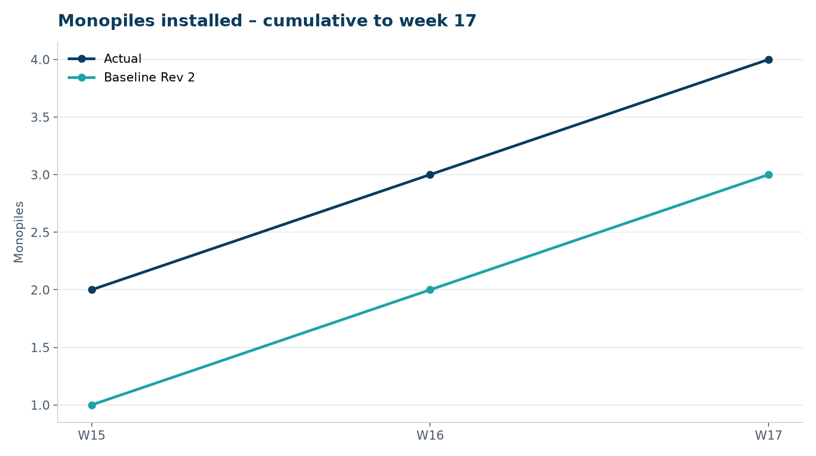
Figure 1 – Monopile installation progress, W15 to W17

3. Key activities this week
- MV Sea Atlas returned to the Port of Eastholm on 21–22 April to load out three monopiles and three transition pieces.
- HB-A04 installed on 25 April. Peak noise reached 160.6 dB SEL at 750 m – a first exceedance; hammer energy reduced and bubble curtain hose re-laid on a tighter radius. Exceedance reported to the regulator within 24 h as required.
- Lessons learned from the first three piles shared with Atlas Marine Contractors and Rhenus Steelworks.

4. Health and safety
No lost time injuries. One near miss reported (minor; closed out on board). 19 observation cards submitted; top theme: line-of-fire during lifts.

5. Environment
- HB-A04: peak 160.6 dB SEL at 750 m (exceedance, reported); harbour porpoise detected in the mitigation zone during the pre-piling search, soft start delayed by 12 min.

6. Issues and risks
- HB-RISK-001 weather: 12 h downtime this week.

7. Look-ahead next week
Install HB-A05 and TP HB-A03/A04; seabird survey no. 4.
Prepared by Project Controls (Gareth Lewis); approved by Elena Márquez. Distribution: project team, Steering Committee, Halden Turbine Systems, Lenders' Technical Adviser.

